Report on Project Design Phase 1

**Machine Learning-Based Predictive Analytics for Aircraft Engine**

**Proposed Solution**

**Problem statement:**

* The unexpected failure of the aircraft engine components leads to increase the overall cost.
* The limitless maintenance activities such as scheduled maintenance (Corrective maintenance, Preventive maintenance, Predictive maintenance) and unscheduled maintenance.

**Idea/Solution Description:**

* To introduce machine learning models based on feature selection and data elimination to predict failure of the aircraft system.
* To minimize the risk factors and improvement of aircraft engine, Engine companies have generated and collected large amount of data over the years from various sources such us the database of currently development projects, previously completed development projects, and the designs that were not manufactured, are valuable for intelligence that can support new engine development.
* To anticipating rare failure within a predetermined meaningful time frame.

**Novelty/Uniqueness**

* Supervised machine-learning analytics for Aircraft engine were employed to find patterns in the database of 183 manufactured engines and engines that were studied previously in various NASA aeronautics projects.
* It minimizes risk and improve in the technological field.
* Based on the analytics airlines can know exactly what is happening, why it is happening, and what possible impact any event.

**Social impact/Customer Satisfaction**

* The database will help the aviation industry and it will need to update for every particular period of time interval (like 10 years…).
* It will make the flight journey even safer.
* It reduces the manual checking of engine components.
* Reduces the cost of repairing.

**Business Model**

**Scalability:**

* The development used the database of 183 manufactured engines and engines that were studied previously in NASA aeronautics projects. The TSFC predictive analytics has an average accuracy of 98.3 percent, with 3.5 percent uncertainty. The engine core-size predictive analytics has an overall accuracy of 100 percent, with 4.3 percent uncertainty. Overall, both predictive analytics show remarkable prediction accuracy.
* It would help to identify the best engine design expeditiously amongst several candidates.

**Table:** Comparative study of the presented machine-learning-based models.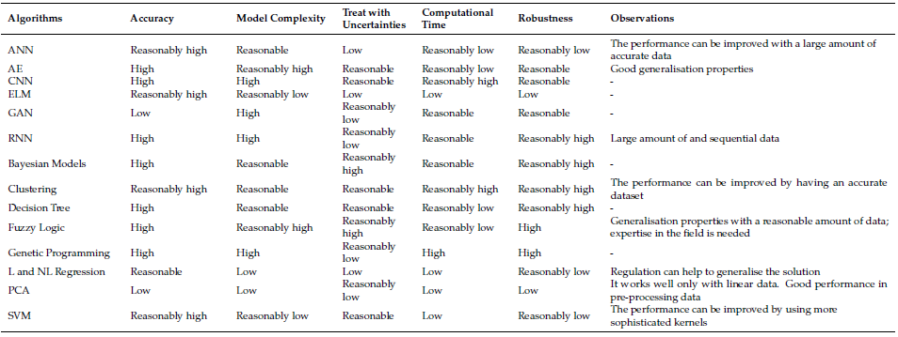

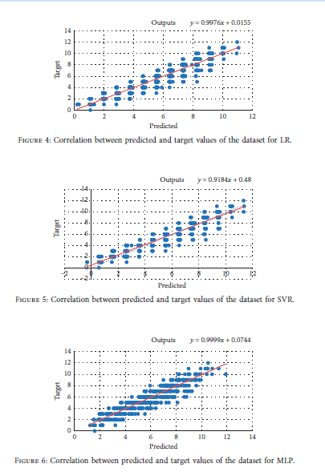

* The results indicate that the proposed hybrid data preparation model significantly improves the accurate prediction of failure counts.
* Comparing AE–CNN–BGRU with other similar deep learning methods, the proposed approach shows superior performance with 18% better precision, 5% in a recall, and 10% in g-mean. The results also indicate the model effectiveness in predicting component failure within a defined useful period that aids in minimising operational disruption.